 Blackfriars Academy, Newcastle under Lyme

Pupil’s Name:

DOB: Year group:

Do you feel that progress is being made towards some or all of the outcomes set out in the EHC Plan? NO

What do you feel has been working well?

What do you feel is not working well and would like to be different?

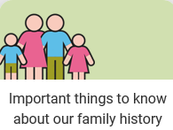
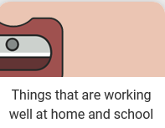
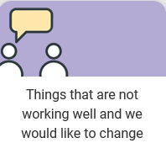
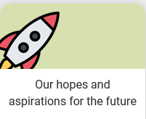
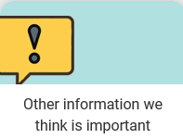

Submitted by: |  | Relationship to young person: |  | Date:

Blackfriars Academy, Newcastle under Lyme
EHCP Annual Review & Preparation for Adulthood
(Y9 and above)

Pupil’s Name: _______________________________________

DOB: ____________________ Year group: _________________

Do you feel that progress is being made towards some or all of the outcomes set out in the EHC Plan? YES / NO

Comments:

What do you feel has been working well?

What do you feel is not working well and would like to be different?

There are 4 main areas of preparing for adulthood.

Please let us have your views about what is important to your child now, and in the future, your child’s aspirations for the future, what you want them to be able to do (e.g. in 2-3 years times) and what do you think would help your child to achieve them?

Further Education and/or Employment

Being Independent / Independent Living

Participating in Social - Friends, Relationships and Community Inclusion

Good Health

Submitted by: | Please print name | Relationship to young person:
Signature: |  |  |  | Date:

